Appendices

Supplementary Appendix 1
Table A1: Table showing the Very Important Tree (VIT) species sampled in the study, with their abbreviations; Species names were updated following the World Checklist of Vascular Plants (WCVP), which provides a current and widely accepted taxonomic framework. Old names of species are also included.

Species name | Species code | Species author | Species former name
Abies alba | Abi alb | Mill. | Abies alba
Abies grandis | Abi gra | (Douglas ex D.Don) Lindl. | Abies grandis
Acer negundo | Ace neg | L. | Acer negundo
Acer platanoides | Ace pla | L. | Acer platanoides
Acer pseudoplatanus | Ace pse | L. | Acer pseudoplatanus
Aesculus hippocastanum | Aes hip | L. | Aesculus hippocastanum
Alnus glutinosa | Aln glu | (L.) Gaertn. | Alnus glutinosa
Betula pendula | Bet pen | Roth | Betula pendula
Carpinus betulus | Car bet | L. | Carpinus betulus
Castanea sativa | Cas sat | Mill. | Castanea sativa
Cedrus deodara | Ced deo | (Roxb. ex D.Don) G.Don | Cedrus deodara
Cormus domestica | Cor dom | (L.) Spach | Sorbus domestica
Corylus colurna | Cor col | L. | Corylus colurna
Fagus sylvatica | Fag syl | L. | Fagus sylvatica
Fraxinus excelsior | Fra exc | L. | Fraxinus excelsior
Juglans regia | Jug reg | L. | Juglans regia
Larix decidua | Lar dec | Mill. | Larix decidua
Picea abies | Pic abi | (L.) H.Karst. | Picea abies
Picea sitchensis | Pic sit | (Bong.) Carrière | Picea sitchensis
Pinus nigra | Pin nig | J.F.Arnold | Pinus nigra
Pinus ponderosa | Pin pon | Douglas ex C.Lawson | Pinus ponderosa
Pinus sylvestris | Pin syl | L. | Pinus sylvestris
Platanus hispanica | Pla his | Mill. ex Münchh. | Platanus acerifolia
Populus tremula | Pop tre | L. | Populus tremula
Prunus avium | Pru avi | (L.) L. | Prunus avium
Pseudotsuga menziesii | Pse men | (Mirb.) Franco | Pseudotsuga menziesii
Quercus pubescens | Que pub | Willd. | Quercus pubescens
Quercus robur | Que rob | L. | Quercus robur
Robinia pseudoacacia | Rob pse | L. | Robinia pseudoacacia
Salix caprea | Sal cap | L. | Salix caprea
Salix fragilis | Sal fra | L. | Salix fragilis
Sorbus aucuparia | Sor auc | L. | Sorbus aucuparia
Taxus baccata | Tax bac | L. | Taxus baccata
Thuja occidentalis | Thu occ | L. | Thuja occidentalis
Tilia cordata | Til cor | Mill. | Tilia cordata
Tilia tomentosa | Til tom | Moench | Tilia tomentosa
Torminalis glaberrima | Tor gla | (Gand.) Sennikov & Kurtto | Sorbus torminalis
Tsuga canadensis | Tsu can | (L.) Carrière | Tsuga canadensis
Ulmus laevis | Ulm lae | Pall. | Ulmus laevis
Ulmus minor | Ulm min | Mill. | Ulmus minor

Table A2: Table showing all species in ARBOfun, as presented in the planting scheme. Species names were updated following the World Checklist of Vascular Plants (WCVP), which provides a current and widely accepted taxonomic framework. Old names of species are also included.
Species name | Species code | Species author | species former name
Abies alba | Abi alb | Mill. | Abies alba
Abies balsamea | Abi bal | (L.) Mill. | Abies balsamea
Abies grandis | Abi gra | (Douglas ex D.Don) Lindl. | Abies grandis
Abies nordmanniana | Abi nor | (Steven) Spach | Abies nordmanniana
Acer campestre | Ace cam | L. | Acer campestre
Acer monspessulanum | Ace mon | L. | Acer monspessulanum
Acer negundo | Ace neg | L. | Acer negundo
Acer opalus | Ace opa | Mill. | Acer opalus
Acer platanoides | Ace pla | L. | Acer platanoides
Acer pseudoplatanus | Ace pse | L. | Acer pseudoplatanus
Acer saccharinum | Ace sac | L. | Acer saccharinum
Aesculus hippocastanum | Aes hip | L. | Aesculus hippocastanum
Alnus cordata | Aln cor | (Loisel.) Duby | Alnus cordata
Alnus glutinosa | Aln glu | (L.) Gaertn. | Alnus glutinosa
Alnus incana | Aln inc | (L.) Moench | Alnus incana
Aria edulis | Ari edu | (Willd.) M.Roem. | Sorbus aria
Betula pendula | Bet pen | Roth | Betula pendula
Betula pubescens | Bet pub | Ehrh. | Betula pubescens
Carpinus betulus | Car bet | L. | Carpinus betulus
Castanea sativa | Cas sat | Mill. | Castanea sativa
Cedrus deodara | Ced deo | (Roxb. ex D.Don) G.Don | Cedrus deodara
Cedrus libani | Ced lib | A.Rich. | Cedrus libani
Celtis australis | Cel aus | L. | Celtis australis
Celtis occidentalis | Cel occ | L. | Celtis occidentalis
Chamaecyparis lawsoniana | Cha law | (A.Murray bis) Parl. | Chamaecyparis lawsoniana
Cormus domestica | Cor dom | (L.) Spach | Sorbus domestica
Corylus avellana | Cor ave | L. | Corylus avellana
Corylus colurna | Cor col | L. | Corylus colurna
Crataegus germanica | Cra ger | (L.) Kuntze | Mespilus germanica
Crataegus laevigata | Cra lae | (Poir.) DC. | Crataegus laevigata
Crataegus monogyna | Cra mon | Jacq. | Crataegus monogyna
Euonymus europaeus | Euo eur | L. | Euonymus europaeus
Fagus orientalis | Fag ori | Lipsky | Fagus orientalis
Fagus sylvatica | Fag syl | L. | Fagus sylvatica
Frangula alnus | Fra aln | Mill. | Frangula alnus
Fraxinus excelsior | Fra exc | L. | Fraxinus excelsior
Fraxinus ornus | Fra orn | L. | Fraxinus ornus
Fraxinus pennsylvanica | Fra pen | Marshall | Fraxinus pennsylvanica
Gleditsia triacanthos | Gle tri | L. | Gleditsia triacanthos
Ilex aquifolium | Ile aqu | L. | Ilex aquifolium
Juglans nigra | Jug nig | L. | Juglans nigra
Juglans regia | Jug reg | L. | Juglans regia
Juniperus communis | Jun com | L. | Juniperus communis
Larix decidua | Lar dec | Mill. | Larix decidua
Larix kaempferi | Lar kae | (Lamb.) Carrière | Larix kaempferi
Malus sylvestris | Mal syl | (L.) Mill. | Malus sylvestris
Morus alba | Mor alb | L. | Morus alba
Morus nigra | Mor nig | L. | Morus nigra
Nyssa sylvatica | Nys syl | Marshall | Nyssa sylvatica
Ostrya carpinifolia | Ost car | Scop. | Ostrya carpinifolia
Picea abies | Pic abi | (L.) H.Karst. | Picea abies
Picea laxa | Pic lax | (Münchh.) Sarg. | Picea glauca
Picea pungens | Pic pun | Engelm. | Picea pungens
Picea sitchensis | Pic sit | (Bong.) Carrière | Picea sitchensis
Pinus cembra | Pin cem | L. | Pinus cembra
Pinus contorta | Pin con | Douglas ex Loudon | Pinus contorta
Pinus mugo | Pin mug | Turra | Pinus mugo
Pinus nigra | Pin nig | J.F.Arnold | Pinus nigra
Pinus ponderosa | Pin pon | Douglas ex C.Lawson | Pinus ponderosa
Pinus strobus | Pin str | L. | Pinus strobus
Pinus sylvestris | Pin syl | L. | Pinus sylvestris
Platanus hispanica | Pla his | Mill. ex Münchh. | Platanus acerifolia
Populus nigra | Pop nig | L. | Populus nigra
Populus tremula | Pop tre | L. | Populus tremula
Prunus avium | Pru avi | (L.) L. | Prunus avium
Prunus mahaleb | Pru mah | L. | Prunus mahaleb
Prunus padus | Pru pad | L. | Prunus padus
Prunus serotina | Pru ser | Ehrh. | Prunus serotina
Pseudotsuga menziesii | Pse men | (Mirb.) Franco | Pseudotsuga menziesii
Pterocarya fraxinifolia | Pte fra | (Poir.) Spach | Pterocarya fraxinifolia
Pyrus communis | Pyr com | L. | Pyrus communis
Quercus cerris | Que cer | L. | Quercus cerris
Quercus frainetto | Que fra | Ten. | Quercus frainetto
Quercus petraea | Que pet | (Matt.) Liebl. | Quercus petraea
Quercus pubescens | Que pub | Willd. | Quercus pubescens
Quercus robur | Que rob | L. | Quercus robur
Quercus rubra | Que rub | L. | Quercus rubra
Robinia pseudoacacia | Rob pse | L. | Robinia pseudoacacia
Salix alba | Sal alb | L. | Salix alba
Salix caprea | Sal cap | L. | Salix caprea
Salix cinerea | Sal cin | L. | Salix cinerea
Salix fragilis | Sal fra | L. | Salix fragilis
Salix pentandra | Sal pen | L. | Salix pentandra
Salix triandra | Sal tri | L. | Salix triandra
Salix viminalis | Sal vim | L. | Salix viminalis
Sambucus nigra | Sam nig | L. | Sambucus nigra
Sambucus racemosa | Sam rac | L. | Sambucus racemosa
Scandosorbus intermedia | Sca int | (Ehrh.) Sennikov | Sorbus intermedia
Sorbus aucuparia | Sor auc | L. | Sorbus aucuparia
Taxus baccata | Tax bac | L. | Taxus baccata
Thuja occidentalis | Thu occ | L. | Thuja occidentalis
Thuja plicata | Thu pli | Donn ex D.Don | Thuja plicata
Tilia cordata | Til cor | Mill. | Tilia cordata
Tilia platyphyllos | Til pla | Scop. | Tilia platyphyllos
Tilia tomentosa | Til tom | Moench | Tilia tomentosa
Torminalis glaberrima | Tor gla | (Gand.) Sennikov & Kurtto | Sorbus torminalis
Tsuga canadensis | Tsu can | (L.) Carrière | Tsuga canadensis
Tsuga heterophylla | Tsu het | (Raf.) Sarg. | Tsuga heterophylla
Ulmus glabra | Ulm gla | Huds. | Ulmus glabra
Ulmus laevis | Ulm lae | Pall. | Ulmus laevis
Ulmus minor | Ulm min | Mill. | Ulmus minor
Zelkova carpinifolia | Zel car | (Pall.) K.Koch | Zelkova carpinifolia

Description of the VIT selection:
During the first part of the selection, three main criteria were applied in order to ensure an adequate replication, size, and spatial representation of individuals within ARBOfun; 1) only species with a minimum of three vital replicates were considered, 2) the tree needed a diameter at breast height (DBH) and height of at least 5cm and 2m, respectively, and 3) species with replicates in Blocks A, B and C (Figure A2, Supplementary Appendix 1) were prioritized. Next, a principal component analyses (PCA) of important morphological, anatomical and physiological above and belowground traits was performed, from traits measured on site between April and June 2023, as well as the Specific Stem Density (SSD) and P50 (the water potential at which hydraulic conductivity is reduced by 50%), from a gap-filled version of the TRY database (Kattge et al., 2020; Kretz et al., 2025). The measured traits include Specific Leaf Area (SLA), Root Tissue Density (RTD), Root Diameter (RD), Leaf Area (LA), Root Nitrogen (RN), Leaf Nitrogen (LN), Stomatal Density (SD), Specific Root Length (SRL), being indicative for resource acquisition and economics (SLA, RN, LN, SRL), structural and tissue investment (SSD, RTD, RD) and hydraulic properties and stress tolerance (P50, SD, LA) (Sanaei et al., 2025; Kretz et al., 2025). From the PCA results, species were selected based on trait- and phylogeny-related criteria; 1) angiosperms and gymnosperms selections were done separately, 2) to get gradients of functional diversity, species at the extremes of major trait gradients were prioritized, 3) to emphasise trait dissimilarity and avoid redundancy, species from different trait clusters were preferentially selected, 4) for cross-platform comparisons, species present in other iDiv-platforms were fixed in the selection, 5) species that were the only representatives of a certain genus were automatically included, 6) congeneric pairs (two species from the same genus) were prioritized if they had contrasting functional traits, 7) to capture environmental and biogeographic variation, congeneric pairs of species originating from different biomes were preferred, and, 8) European species were prioritized over alien species. The final selection consists of 27 angiosperms and 13 gymnosperms.
Details of soil horizons, identified from the soil cores:
From the soil cores, clear profiles were identified up to 130 cm; the youngest part of the topsoil (0-17 cm) is a humus-rich mineral horizon with clear enrichment of organic matter, whilst the second topsoil layer (17-30 cm) is a relictic plow or cultivation horizon. Both topsoil layers had a fairly high supply of phosphorus, especially compared to the undersupplied horizons below. From 30-42 cm is a whitish, eluvial horizon (diagnostic for Albeluvisols), showing stagnic characteristics, followed by a transition horizon (42-63 cm), characterised by illuvial processes and incipient clay enrichment, including aggregate coatings. Finally, the deeper horizons (63-300 cm below surface) are characterized by stagnic properties, which provide evidence of periodic waterlogging, as they exhibit redox characteristics. Overall, the soil profile is acidic, with pH values well below 6, and is completely carbonate free. This land, previously used for agriculture, has C:N ratios (10-12) in the upper horizons which are typical of productive arable soils in Central Europe (Scheffer & Schachtschabel, 2018). From grain size analyses, the fine soil can be classified as sandy loam in the topsoil and loamy sand in the subsoil.
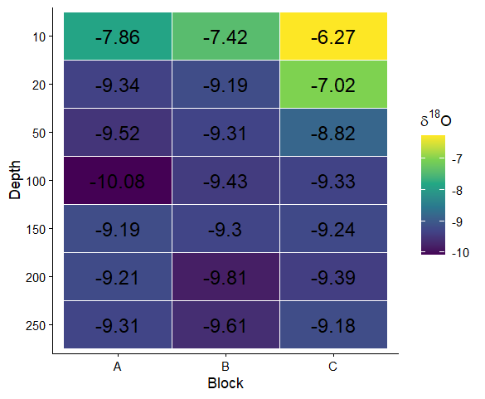
Figure A1: Heatmap showing the mean soil water δ18O (‰) for each Block × Depth combination, calculated from samples collected on 30 June and 4 August 2025. Tile colours represent the magnitude of mean δ18O values, while the numbers within tiles indicate the corresponding mean δ18O (‰).
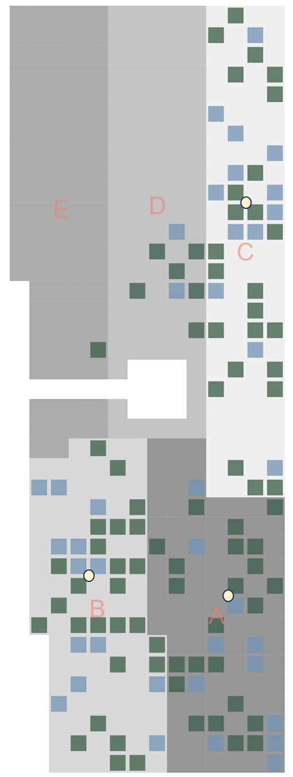
Figure A2: Rough map of the ARBOfun layout, including the Blocks (A-E). Individual trees are represented by single blocks, with the VITs (Very Important Trees) coloured by clade; green = angiosperms and blue = gymnosperms. The 3 locations for soil sampling are indicated with yellow dots.

Supplementary Appendix 2
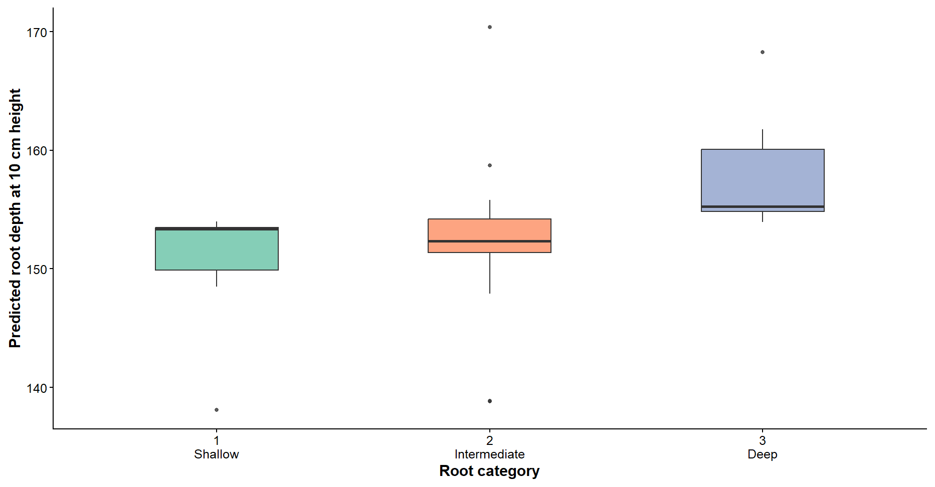
Figure A3: Boxplots showing the predicted root depth at 10m height (used as the final root index in the model), for each root category (defined using the “Wurzelatlas mitteleuropäischer Waldbäume und Sträucher” by Kutschera & Lichtenegger (2002)).

Supplementary Appendix 3
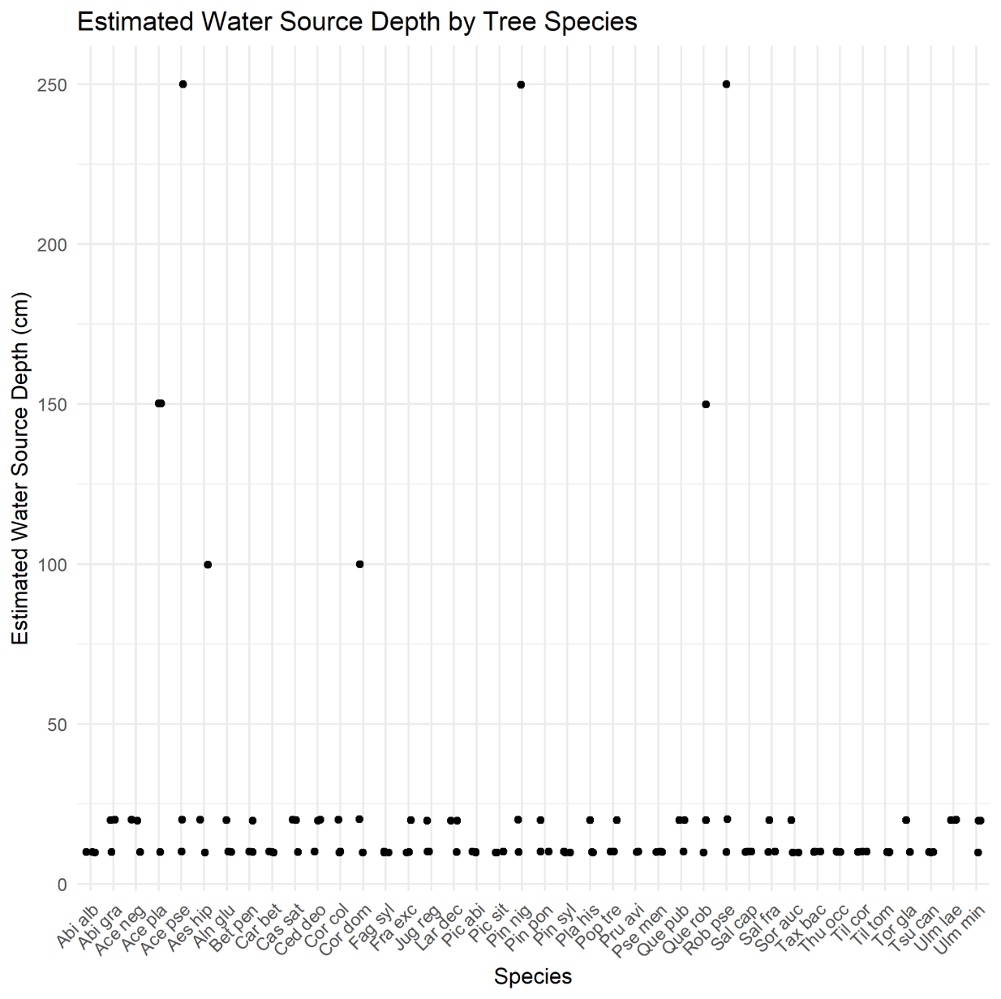
Depth | mean δ¹⁸O_{soil}
10 | -8.12
20 | -8.90
50 | -9.32
100 | -9.57
150 | -9.29
200 | -9.43
250 | -9.44

Figure A4: Plot showing the estimated water source depth of the individual trees by species. The estimated depth was calculated by comparing the twig water δ¹⁸O (δ¹⁸O_{twig} ) to the mean δ¹⁸O of the soil (δ¹⁸O_{soil} ) for each depth. The soil depth resulting in the lowest difference was used as an indicator of the estimated water source depth (y-axis). The table shows the mean δ¹⁸O_{soil} calculated for each depth.
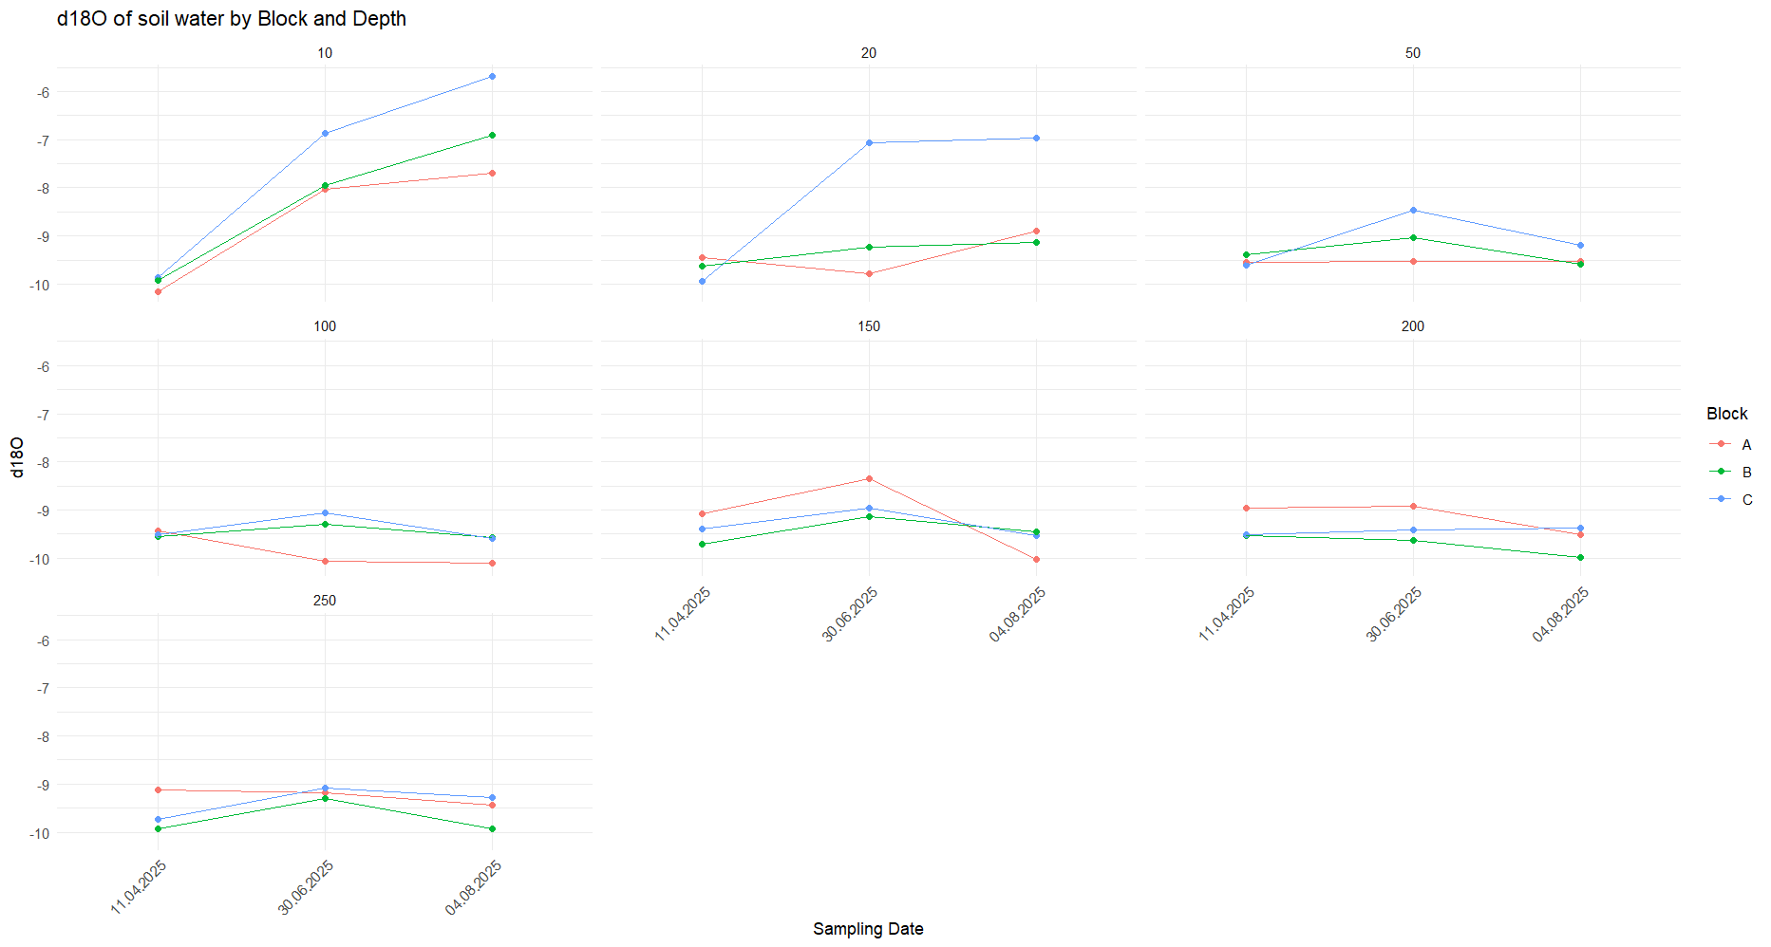
Figure A5: Change in δ18O of the soil water (δ18O_{soil}) for the three sampling locations, over the three sampling dates layer whose mean soil water δ¹⁸O most closely matched the twig water δ¹⁸O.

Supplementary Appendix 4
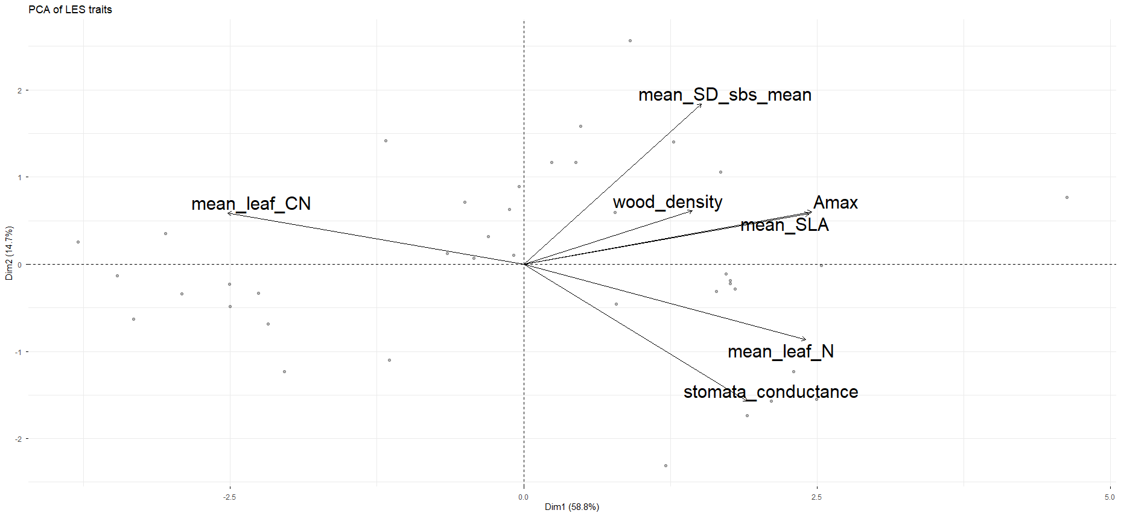
Figure A6: Principal Component Analysis (PCA) of seven traits related to the slow-fast gradient, for 76 tree species. For Specific Leaf Area (SLA), leaf Nitrogen content (leaf N), Carbon to Nitrogen ratio (leaf CN) and stomatal density (SD_sbs_mean), the mean was calculated from trait measurements of individuals within the same species. For wood density, stomatal conductance and photosynthetic capacity (Amax), values were taken from the TRY database.
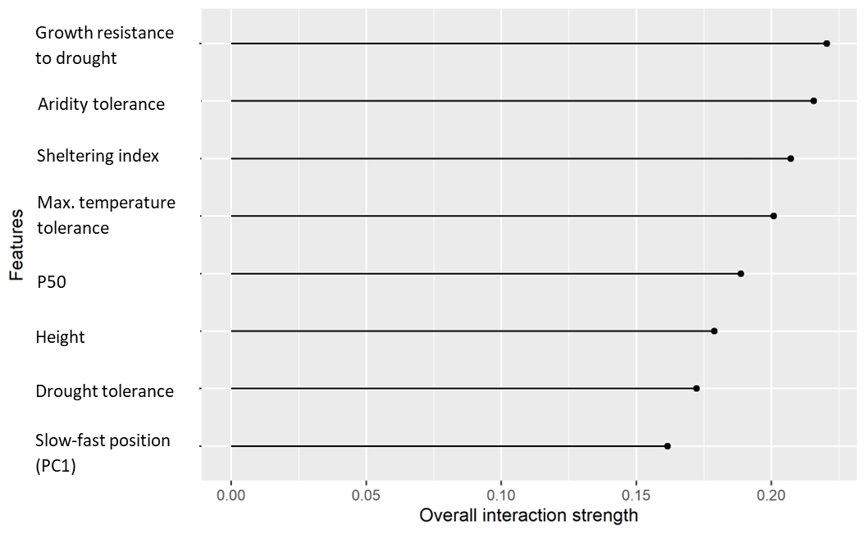
Figure A7: Interaction strength of random forest model variables (growth resistance to drought, aridity tolerance index, sheltering index, maximum heat tolerance index, P50 (xylem vulnerability to embolism), height, drought tolerance and slow-fast position (PC1), respectively).

